**Task 1 - Alteryx Workflows**

**Part 1:**

Task_1_Preparing_The_Data.yxmd

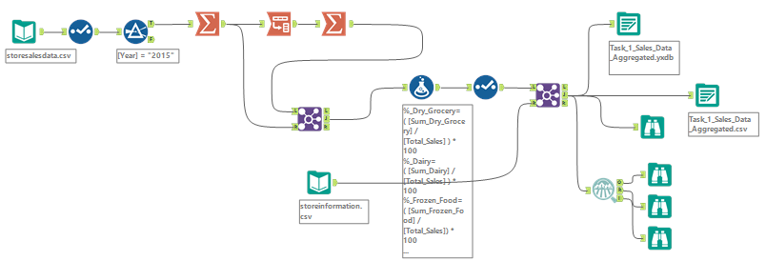

**Part 2:**

Task_1_Clustering.yxmd

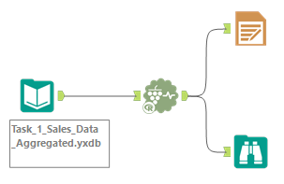

**Part 3:**

Task_1_Cluster_Analysis.yxmd

